AFFIDAVIT IN SUPPORT OF ASYLUM FOR NDIP OTUN ETTA
I, Chebet Wusaira a citizen of Uganda, solemnly swear that the following is true to the best of my knowledge and belief.
Uganda and Cameroon are governed by entrenched authoritarian regimes whose presidents have ruled for decades and seek to remain in power indefinitely. Uganda’s president has held office since 1986, and Cameroon’s president since 1982. Elections, courts, and security institutions are routinely manipulated to suppress opposition and punish perceived dissent.
In Uganda, individuals associated with opposition politics or critical speech are subjected to surveillance, arbitrary arrest, prolonged detention, and torture, including beatings, electrocution, and detention in unofficial facilities without due process. Persecution is commonly based on actual or imputed political opinion. Cameroon employs similar methods against critics and activists.
NDIP OTUN ETTA is a Cameroonian national with a perceived opposition profile. Applying the asylum standard articulated in INS v. Cardoza-Fonseca, a well-founded fear requires only a reasonable possibility of persecution, not proof that harm is more likely than not. Given country conditions, there is a reasonable possibility NDIP OTUN ETTA would be detained, abused, or forcibly returned to Cameroon.
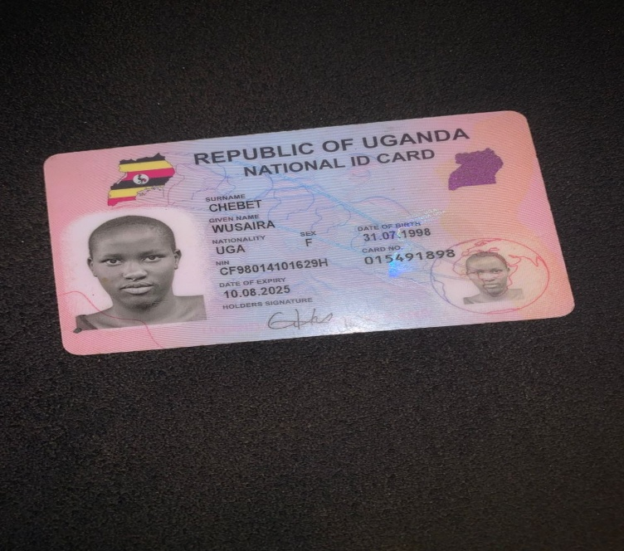
Chebet Wusaira
26/01/2026

